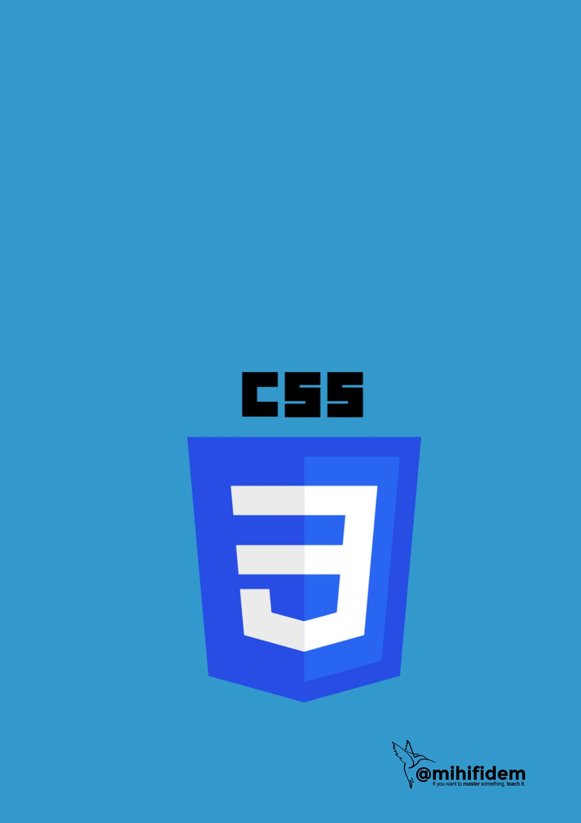

CSS

Ejercicio dirigido

Calculadora iPhone

**1.- Tabla HTML**

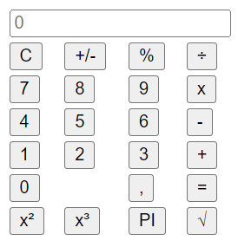

**Index.html**

<table>

<tr>

<td colspan="4">

<form>

<input class="input" id="input" placeholder="0">

</form>

</td>

</tr>

<tr>

<td>

<button class="lightButton" >C</button>

</td>

<td>

<button class="lightButton">+/-</button>

</td>

<td>

<button class="lightButton" >%</button>

</td>

<td>

<button class="acentButton" >÷</button>

</td>

</tr>

<tr>

<td>

<button class="darkButton" >7</button>

</td>

<td>

<button class="darkButton" >8</button>

</td>

<td>

<button class="darkButton" >9</button>

</td>

<td>

<button class="acentButton" >x</button>

</td>

</tr>

<tr>

<td>

<button class="darkButton" >4</button>

</td>

<td>

<button class="darkButton" >5</button>

</td>

<td>

<button class="darkButton" >6</button>

</td>

<td>

<button class="acentButton" >-</button>

</td>

</tr>

<tr>

<td>

<button class="darkButton" >1</button>

</td>

<td>

<button class="darkButton" >2</button>

</td>

<td>

<button class="darkButton" >3</button>

</td>

<td>

<button class="acentButton" >+</button>

</td>

</tr>

<tr>

<td colspan="2">

<button class="ceroButton darkButton" >0</button>

</td>

<td>

<button class="darkButton" >,</button>

</td>

<td>

<button class="acentButton" >=</button>

</td>

</tr>

<tr>

<td>

<button class="acentButton" >x&#178</button>

</td>

<td>

<button class="acentButton" >x&#179</button>

</td>

<td>

<button class="acentButton" >PI</button>

</td>

<td>

<button class="acentButton" >&radic;</button>

</td>

</tr>

</table>

.

1. **Reset CSS**

## * {

margin: 0px; padding: 0px;

}

1. **Estilo a los botones en general .**

button { width: 60px;

height: 60px;

border-radius: 60px; border: none; margin: 2px;

font-size: 30px; font-weight: 250;

}

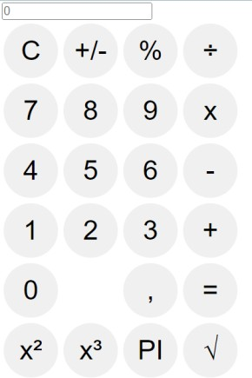

1. **Estilo al display de entrada/salida**

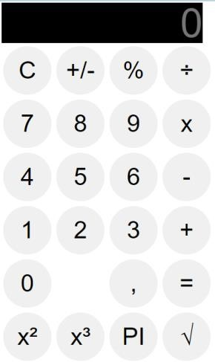

.input{

border:none; width: 250px; height: 50px; font-size: 50px; text-align: right;

background-color: black; color: white;

font-weight: 100;

}

1. **Estilo botón doble (0)**

.ceroButton { width: 100%; text-align: left;

padding-left: 25px;

}

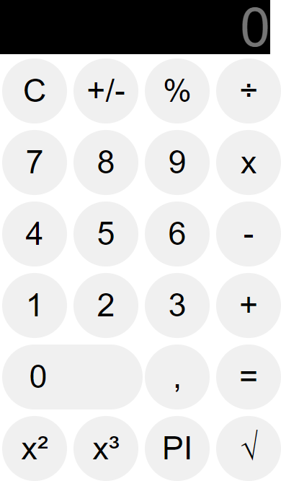

1. **Botones light**

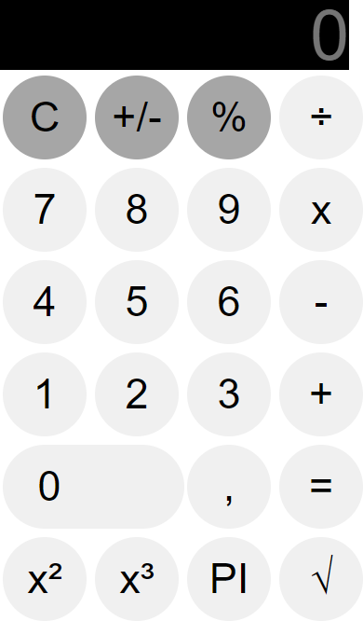

.lightButton {

background-color: #a6a6a6; color: black;

}

1. **Botones dark (números)**

.darkButton {

background-color: #333333; color: white;

}

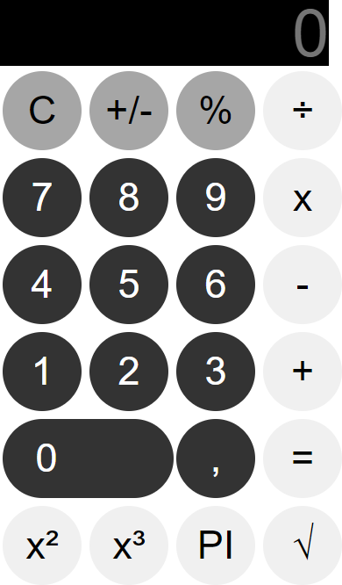

1. **Botones acent**

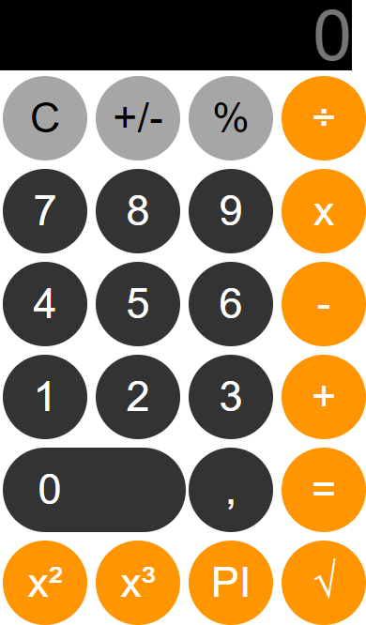

.acentButton {

background-color: #ff9501; color: white;

}

1. **Body**

body {

position: absolute; top: 50%;

left: 50%;

transform: translateX(-50%) translateY(- 50%);

background-color: black;

}

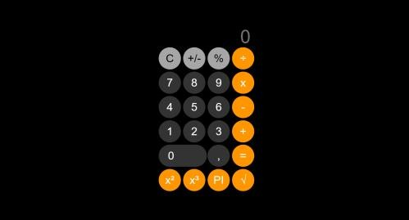

1. **Display**

.input { border: none; width: 250px;

font-size: 50px; text-align: right;

background-color: black; color: white;

font-weight: 200;

}

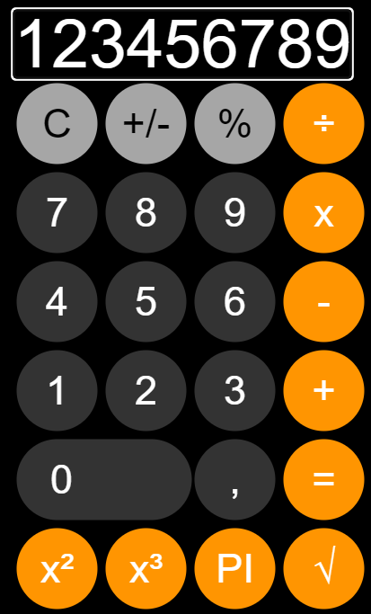

1. **Display color blanco**

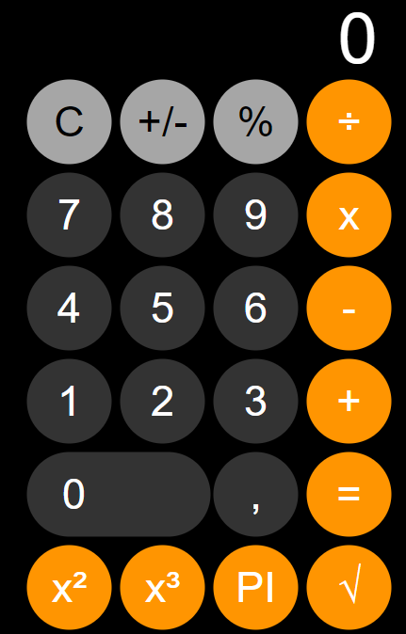

::-webkit-input-placeholder { color: white;

}

# Tutorial calculadora iphone